1. **Purpose**

This program is supposedly implemented in a booth called ABC Chat Time. It offers the customers 3 types of beverages with different prices. After the customers choose the desired beverage, they can choose to add extra milk, and then the quantity of the beverage. Of course, the customers can add different beverages after their first choice, and choose to add extra milk, and the quantity of the beverage. The total of each beverage choice will displayed after the customer choose the beverage choice and choice to add extra milk. The grand total of the purchase of customers will be displayed after the customer choose the beverage choice, choice to add extra milk, and the quantity of the beverage. It will also be displayed at the end of the program after the customers choose to add orders or not.

1. **Analysis**

|  |  |  |
| --- | --- | --- |
| **Input** | **Process** | **Output** |
| **Options of beverages:**  ‘1’ for Espresso, ‘2’ for Cappuccino, ‘3’ for Latte  Extra milk:  ‘Y’ for yes or ‘N’ for no  Quantity of beverage  Add order:  ‘Y’ for yes or ‘N’ for No | **Formula:**  Espresso + extra milk = 2.10 + 0.50  Cappuccino + extra milk = 2.20 + 0.50  Latte + extra milk = 2.30 + 0.50  FINAL_TOTAL = (TOTAL * QUANTITY) + FINAL_TOTAL | Customer’s choice of beverage  Customer’s choice of extra milk  Price of beverage    Quantity of beverage  Grand total of customer’s order |
| **Variable Name** | **Data Type** |  |
| BEVERAGE (beverage type)  QUANTITY (quantity of beverage)  EXTRA_MILK (addition of extra milk)  WANT_MORE_ORDER (addition of order)  TOTAL (total price for each beverage)  FINAL_TOTAL (grand total for customer’s order) | int  int  char  char  float  float |  |

1. **Flowchart**

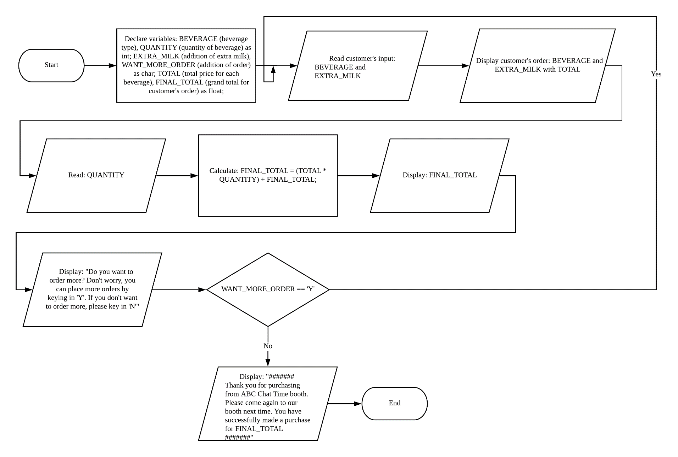

1. **Pseudocode**
2. Start
3. Declare variables: BEVERAGE, QUANTITY, EXTRA_MILK,

WANT_MORE_ORDER, TOTAL, FINAL_TOTAL

1. Read: BEVERAGE and EXTRA_MILK
2. Display: BEVERAGE and EXTRA_MILK with TOTAL
3. Read: QUANTITY
4. Calculate: FINAL_TOTAL = (TOTAL * QUANTITY) + FINAL_TOTAL
5. Display: FINAL_TOTAL
6. Display: "Do you want to order more? Don't worry, you can place more orders by keying in 'Y'. If you don't want to order more, please key in 'N'"

8.1 Read condition: WANT_MORE_ORDER

8.2 While WANT_MORE_ORDER == ‘Y’

8.3 Do loop (Repeat from step 3.0, which is Read: BEVERAGE and

EXTRA_MILK)

For false

8.4 Exit loop

9.0 Display: "####### Thank you for purchasing from ABC Chat Time booth. Please

come again to our booth next time. You have successfully made a purchase for

FINAL_TOTAL #######"

10.0 End

1. **Code**

#include <stdio.h>

void FUNCTION_FINAL_TOTAL();

int BEVERAGE, QUANTITY;

char EXTRA_MILK, WANT_MORE_ORDER;

float TOTAL, FINAL_TOTAL;

main()

{

printf("xxxxxxxxxxxxxxxxxxxxxxxxxxxxxxxxxxxxxxxxxxxxxxxxxxxxxxxxxxx\n");

printf("W E L C O M E T O A B C C H A T T I M E B O O T H\n");

printf("xxxxxxxxxxxxxxxxxxxxxxxxxxxxxxxxxxxxxxxxxxxxxxxxxxxxxxxxxxx\n");

printf("\n\tWe offer 3 types of beverages which are:\n\n");

printf("\t\t-----------------------\n");

printf("\t\t1. Espresso (RM 2.10)\n");

printf("\t\t2. Cappuccino (RM 2.20)\n");

printf("\t\t3. Latte (RM 2.30)\n");

printf("\t\t-----------------------\n");

printf("\nxxxxxxxxxxxxxxxxxxxxxxxxxxxxxxxxxxxxxxxxxxxxxxxxxxxxxxxxxxx\n");

do{

printf("\n\n\t<<< STEP 1 >>>\n\n");

printf("\nWhich beverage do you want? Key in '1' for Espresso, '2' for Cappucino, or '3' for Latte\n");

printf("==> ");

scanf("%d", &BEVERAGE);

printf("\n\n\t<<< STEP 2 >>>\n\n");

if(BEVERAGE == 1){

printf("\nDo you want to add extra milk to your Espresso for an extra RM 0.50 charge?");

printf("\nPlease key in 'Y' for yes or 'N' for no\n");

printf("==> ");

scanf("%s", &EXTRA_MILK);

if(EXTRA_MILK == 'Y'){

printf("\nYour choice is Espresso with extra milk");

TOTAL = 2.60;

printf("\nThe price for your beverage would be: RM %.2f", TOTAL);

}

else{

printf("\nYour choice is Espresso only");

TOTAL = 2.10;

printf("\nThe price for your beverage would be: RM %.2f", TOTAL);

}

}

else if(BEVERAGE == 2){

printf("Do you want to add extra milk to your Cappucino for an extra RM 0.50 charge?");

printf("\nPlease key in 'Y' for yes or 'N' for no\n");

printf("==> ");

scanf("%s", &EXTRA_MILK);

if(EXTRA_MILK == 'Y'){

printf("\nYour choice is Cappucino with extra milk");

TOTAL = 2.70;

printf("\nThe price for your beverage would be: RM %.2f", TOTAL);

}

else{

printf("\nYour choice is Cappucino only");

TOTAL = 2.20;

printf("\nThe price for your beverage would be: RM %.2f", TOTAL);

}

}

else if(BEVERAGE == 3){

printf("Do you want to add extra milk to your Latte for an extra RM 0.50 charge?");

printf("\nPlease key in 'Y' for yes or 'N' for no\n");

printf("==> ");

scanf("%s", &EXTRA_MILK);

if(EXTRA_MILK == 'Y'){

printf("\nYour choice is Latte with extra milk");

TOTAL = 2.80;

printf("\nThe price for your beverage would be: RM %.2f", TOTAL);

}

else{

printf("\nYour choice is Latte only");

TOTAL = 2.30;

printf("\nThe price for your beverage would be: RM %.2f", TOTAL);

}

}

else{

printf("\nUh oh! You did not choose from the provided beverage options. <<< STEP 2 >>> could not be carried out successfully.");

printf("\nPlease place your order again by closing this window and reopening it");

return 0;

}

printf("\n\n\n\t<<< STEP 3 >>>\n\n");

printf("\nHow many of this beverage do you want?\n");

printf("==> ");

scanf("%d", &QUANTITY);

FUNCTION_FINAL_TOTAL();

printf("\nThe grand total of your order would be: RM %.2f", FINAL_TOTAL);

printf("\n\n\n\t<<< STEP 4 >>>\n\n");

printf("\nDo you want to order more?");

printf(" Don't worry, you can place more orders by keying in 'Y'. If you don't want to order more, please key in 'N'\n");

printf("==> ");

scanf("%s", &WANT_MORE_ORDER);

}while (WANT_MORE_ORDER == 'Y');

printf("\n####### Thank you for purchasing from ABC Chat Time booth. Please come again to our booth next time. You have successfully made a purchase for RM %.2f #######\n", FINAL_TOTAL);

return 0;

}

void FUNCTION_FINAL_TOTAL()

{

FINAL_TOTAL = (TOTAL * QUANTITY) + FINAL_TOTAL;

}

1. **Output**

